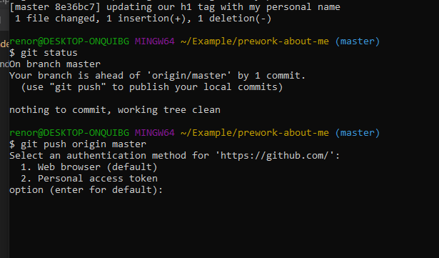

My first push attempt resulted in the above prompt for 2 stage authentication.

Nevertheless, it worked: <https://palexander227.github.io/prework-about-me/>